Maybe Flink is not best practice for SMaRT application

hi, Patrix & Tao & Terry

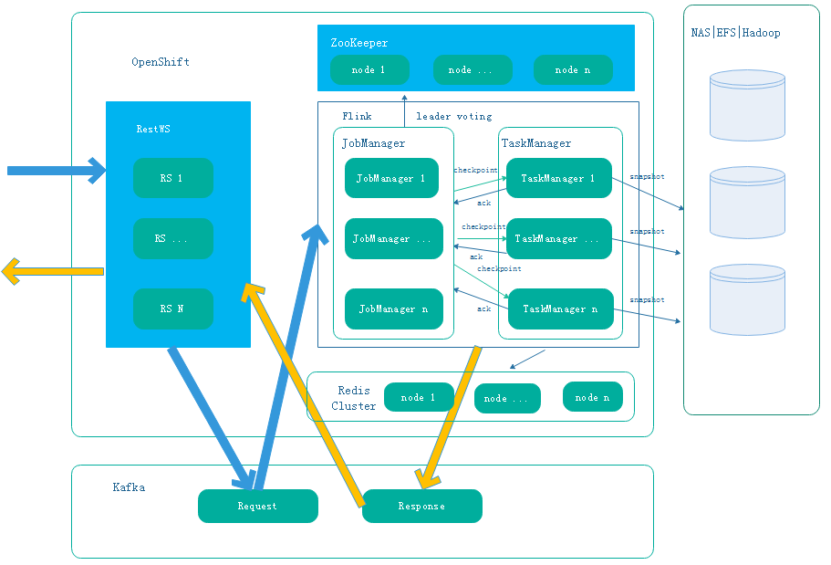

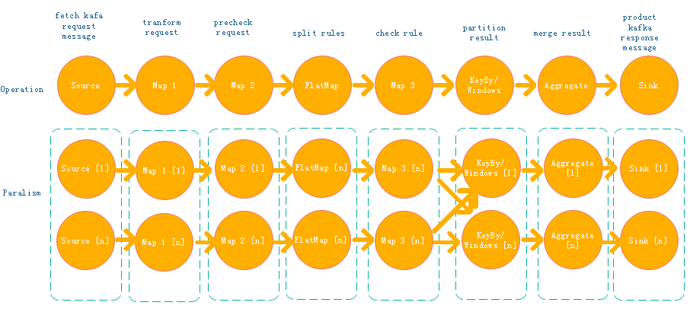

1. Hign avaliabligty will bring the system too complex
2. Scalibitiy is not so good
3. Kafka’s performance is used.
4. 